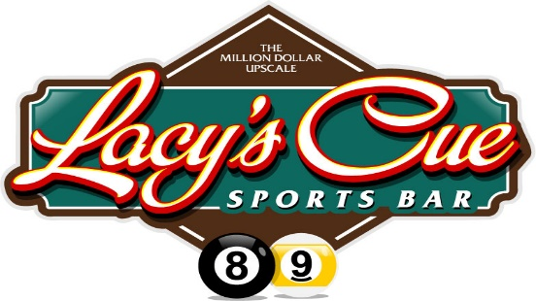 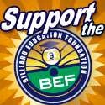 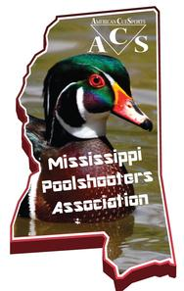

**BILLIARDS EDUCATION FOUNDATION (BEF)**

**BEF MISSISSIPPI REGIONAL JUNIOR NATIONAL 9-BALL QUALIFIER**

**FORMAT: DIVISIONS:**

**DOUBLE ELIMINATION 18 & UNDER (B-G) / 16 & UNDER (B-G) / 14 & UNDER (B-G) / 11 & UNDER CO-ED**

**(# OF RACES TBD ON NUMBER OF ENTRIES) (ACTUAL DIVISIONS PLAYED TBD ON NUMBER OF ENTRIES)**

**ENTRY FEES AND REQUIREMENTS:**

**$10 BEF MEMBERSHIP FEE IF NOT A MEMBER**

**$25 QUALIFIER ENTRY FEE**

**MUST HAVE PROOF OF BIRTH DATE (BIRTH CERTIFICATE REQUIRED)**

**REGISTER ON SITE OR ON-LINE AT BILLIAREDUCATION.ORG**

**LOCATION & DATES:**

**1. BILLIARDS AND BISTRO, VANCLEAVE MS APRIL 21, 2018 - SATURDAY 9AM**

**2. LACY’S CUE, CHALMETTE LA APRIL 28, 2018 - SATURDAY 9AM**

**WEBSITE: Lacy'sscue.com PHONE NUMBER: 504-682-6199**

**RULES: WORLD STANDARIZED RULES, 9-BALL**

**SPONSORED BY ACS - MISSISSIPPI POOLSHOOTERS ASSOCIATION (MPA)**

**FOR ENTRY AND INFORMATION, PLEASE CONTACT/LEAVE A MESSAGE**

**DENNIS STOTLER – 228.297.2292 OR DORIS STOTLER – 228.380.2292**

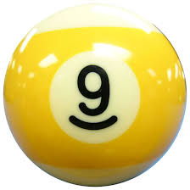 **BEF JUNIOR NATIONAL 9-BALL CHAMPIONSHIP** 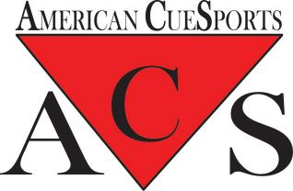

**LOCATION: MORIAL CONVENTION CENTER, NEW ORLEANS, LA**

**JULY 10-14, 2018**

